CSE 3200: System Development Project

**DEVELOPMENT OF A SMART RAILWAY TRAFFIC**

**CONTROL SYSTEM FOR BANGLADESH**

By

### Asif Akbar

Roll: 2007106

**&**

### Shaeer Musarrat Swapnil

Roll: 2007116



#### Department of Computer Science and Engineering Khulna University of Engineering & Technology Khulna 9203, Bangladesh

**August,2025**

**DEVELOPMENT OF A SMART RAILWAY TRAFFIC**

**CONTROL SYSTEM FOR BANGLADESH**

By

### Asif Akbar

Roll: 2007106

**&**

### Shaeer Musarrat Swapnil

Roll: 2007116

#### Supervisor

**Dr. Muhammad Sheikh Sadi**

Professor

Department of Computer Science & Engineering Khulna University of Engineering & Technology

Signature

**Department of Computer Science and Engineering Khulna University of Engineering & Technology Khulna 9203, Bangladesh**

**August,2025**

## Acknowledgment

First of all, we thank the Almighty Allah for blessing us with the skills and abilities required to undertake and successfully complete this project. We are truly grateful for the divine blessings that have allowed us to make a meaningful contribution to the field of Bangladesh Railway Signaling Systems.

We deeply appreciate Dr. Muhammad Sheikh Sadi, Professor in the Department of Computer Science and Engineering, for his invaluable guidance and support throughout this project. His expertise and constant encouragement have been pivotal in the development of the smart railway signaling system. His constructive feedback has greatly shaped the progress of our work.

We are truly grateful for his unwavering mentorship. Without his motivation and dedication, this project’s successful completion would not have been possible. His commitment to fostering a positive learning environment has been a continuous source of inspiration.

Additionally, we would like to acknowledge the invaluable support provided by the railway officers and staff at Ishwardi Railway Station. Their cooperation during the field visits greatly enhanced our understanding of the real-world aspects of railway operations, which were crucial for shaping the practical elements of this project.

This project has been a collaborative effort, and we acknowledge the contributions of all those who have supported and inspired us throughout this endeavor.

**Asif Akbar**

**Roll:2007106**

**Shaeer Musarrat Swapnil**

**Roll:2007116**

## Abstract

The current signaling system of Bangladesh Railway is primarily manual, leading to inefficiencies, human error, and safety risks. The existing system, including mechanical and electro-mechanical interlocking, relies heavily on human intervention and complex wiring, making it prone to errors and delays. Additionally, traditional signaling methods like the Absolute Block System and manual point machine operations further contribute to operational inefficiencies. This project aims to address these challenges by developing a hardware prototype for an automated signaling system. The prototype features DC-based track circuits to detect train occupancy across four tracks, with automation integrated for four types of signals: Outer, Home, Starter, and Advanced Starter. The signaling system is controlled by ESP-32 microcontrollers, which adjust signal states based on real-time track occupancy. Additionally, the project incorporates point machine operation using servo motors and Arduino, allowing manual control of track switching, ensuring trains follow their designated paths. By automating train detection and signaling, the system enhances operational efficiency and safety, reducing the risk of human error. This prototype serves as a model for modernizing Bangladesh Railway's signaling infrastructure, offering a step toward full automation in the future, and improving both the safety and reliability of train operations across the network.

# Contents

#### PAGE

Title Page i

Acknowledgement ii

Abstract iii

Contents iv

List of Tables viii

List of Figures ix

**CHAPTER I Introduction** **1**

1.1 Background 1

1.2 Objectives 1

1.3 Scopes 2

1.4 Unfamiliarity of the problem 2

1.5 Project planning and Work Distribution 2

1.6 Applications of the Work 3

1.7 Organization of the Project 4

#### CHAPTER II Related Works 5

2.1 Introduction 5

2.2 Existing solutions 5

2.3 Solutions to mitigate the gap in existing works 6

2.4 Discussion 6

#### CHARPTER III Methodology 8

3.1 Introduction 8

3.2 Detailed Methodology 8

3.2.1 System Design and Analysis 9

3.2.2 Components Used 9

3.2.3 System Workflow 12

3.2.4 Software Development 12

3.2.5 Testing and Evaluation 12

3.3 Overall Framework/Flowchart 13

3.4 Summary 14

#### CHAPTER IV Implementation, Result and Discussions 15

4.1 Introduction 15

4.2 Evaluation Metrics 15

4.3 Experimental Setup 15

4.4 Dataset 16

4.5 Implementation and Results 17

4.5.1 Track Circuit Implementation 17

4.5.2 Signal System Implementation 17

4.5.3 Point Machine Implementation 17

4.6 Qualitative Results 18

4.7 Quantitative Results 19

4.8 Objective Achieved 19

4.9 Summary 19

#### CHAPTER V Societal, Health, Environment, Safety, Ethical, Legal 20

#### and Cultural Issues

5.1 Intellectual Property Considerations 21

5.2 Ethical Considerations 21

5.3 Safety Considerations 21

5.4 Legal Considerations 21

5.5 Impact of the project on Social, Health, and Cultural 21

Issues

5.5.1 Societal Impact 22

5.5.2 Health Impact 22

5.5.3 Cultural Impact 22

5.6 Impact of Project on the Environment and Sustainability 22

5.6.1 Environmental Impact 22

5.6.2 Sustainability Impact 22

**CHAPTER VI Addressing Complex Engineering Problems and** **23**

**Activities**

6.1 Introduction 23

6.2 Complex Engineering Problem Associated with the current 23

project

6.2.1 Track Detection Accuracy 23

6.2.2 Signal Interlocking and Conflict Prevention 23

6.2.3 Point Machine Simulation 24

6.3 Complex Engineering Problems Associated with 24

the Current Project

6.3.1 Prototyping & Testing 24

6.3.2 System Integration and Coordination 24

6.3.3 Real-Time Data Monitoring 24

6.3.4 Software Development for Control 25

6.4 Summary 25

**CHAPTER VI Conclusions** **26**

7.1 Concluding Remarks 26

7.2 Limitations 26

7.3 Future Work 27

7.4 Summary 28

**REFERENCES** **29**

# List of Tables

|  |  |  |
| --- | --- | --- |
| **Table No.** | **Description** | **Page** |
| 1.1 | Work Distributions | 2 |
| 2.1 | Comparison of the automated railway signaling system, highlighting its key features and limitations | 7 |
| 2.2 | System Components | 11 |
| 4.1 | Quantitative Result | 19 |

# List of Figures

**Figure No. Description Page**

1.1 Gantt Chart for the Railway System Development and Progress. 3

* 1. ESP-32 Microcontroller 10
  2. Arduino Uno 10
  3. DC-Based Track Circuit 10
  4. Servo Motor 11

3.5 Signal LED 11

3.6 Flow Chart of the System 14

4.1 Circuit diagram for the signaling and track circuit 18

# CHAPTER 1

## Introduction

#### Background

Bangladesh Railway plays a crucial role in the transportation system, providing an essential means of travel for people and goods across the country. However, the existing signaling system, which relies on manual operations and mechanical interlocking, presents several challenges, including inefficiency, safety risks, and human error.[1] This project aims to address these challenges by introducing automation into the signaling system, thereby improving operational efficiency, safety, and reducing the potential for mistakes. By developing a hardware prototype for automated signaling, the project contributes to the modernization of Bangladesh Railway's signaling infrastructure.[2]

#### Objectives The objectives of this project are:

* + - to automate the existing manual signaling system used in Bangladesh Railway.
    - to develop a functional prototype that includes DC-based track circuits, automated signaling, and point machine operation.
    - to enhance the safety and operational efficiency of train movements on a small-scale model of the railway network.
    - to demonstrate the potential for future expansion of automation to other regions of the network.

#### Scopes

This project focuses on the design and implementation of a hardware prototype for a small section of Bangladesh Railway's signaling system. The scope includes:

* The development of DC-based track circuits for real-time train occupancy detection.
* The automation of signaling with four types of signals: Outer, Home, Starter, and Advanced Starter.
* The demonstration of point machine operation using servo motors and Arduino to switch tracks.
* Testing and evaluating the performance of the prototype on a small-scale railway system.

#### Unfamiliarity of the problem

Bangladesh Railway's current signaling system is largely manual and lacks automation, leading to inefficiencies and safety concerns. Automation in railway signaling is a relatively unexplored area in the country, with limited local expertise and infrastructure to support it. This project introduces an innovative solution that integrates modern technologies, such as ESP-32 microcontrollers and servo motors, into the railway system. By developing this hardware prototype, we aim to bridge the gap in knowledge and technology in Bangladesh Railway's signaling system.[3]

Previous studies have highlighted that real-time train tracking and automatic signal coordination can drastically reduce these risks (Kumar, Rajalakshmi, and Babu, 2018).

#### Project Planning and Work Distribution

The project was completed collaboratively by two team members. The work was divided based on hardware design, coding, circuit development, and physical construction of the model railway system. The main responsibilities were distributed as follows:

Table 1.1: Work Distributions

|  |  |
| --- | --- |
| **Tasks** | **Contributors** |
| Track circuit design and implementation | Asif Akbar |
| Signal integration | Shaeer Musarrat Swapnil |
| ESP32 programming and logic development | Asif Akbar &  Shaeer Musarrat Swapnil |
| Model construction and circuit wiring | Asif Akbar &  Shaeer Musarrat Swapnil |
| Software simulation (external collaboration) | External developer/team |

A simplified work plan was followed, with an early focus on research and design, followed by hardware prototyping, testing, and demonstration. The collaborative nature of the project ensured balanced workload distribution and mutual understanding of the entire system.

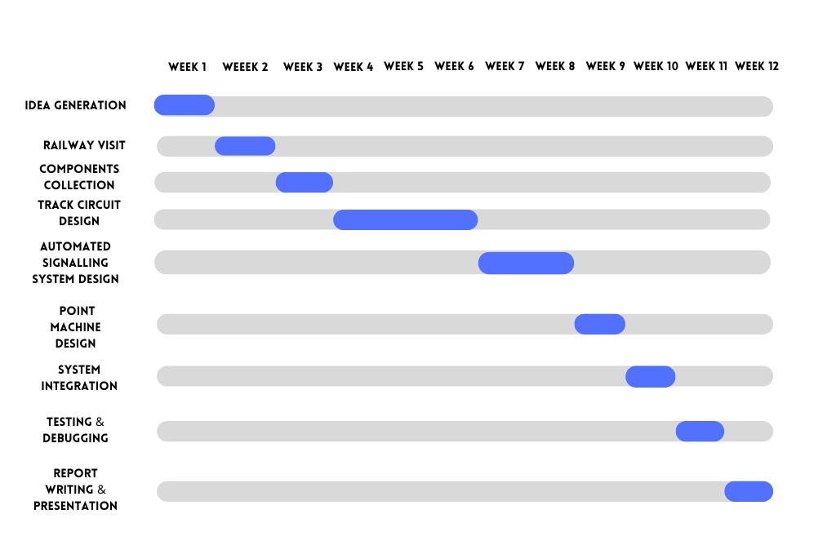Figure 1.1: Gantt chart for the Railway System Development and Progress.

#### Applications of the Work

The outcomes of this project have broad applications in the railway sector, including:

* **Safety Improvement**: By automating signaling and track switching, the system reduces the chances of human error and enhances safety.
* **Operational Efficiency**: Automation streamlines train operations, reducing delays and improving scheduling.
* **Scalability**: The developed prototype can serve as a foundation for automating larger sections of the Bangladesh Railway network, contributing to long-term modernization goals.
* **Cost Savings**: By reducing the need for manual operations and minimizing human errors, the system can potentially lower operational costs in the long run.

#### Organization of the Project

The report of this project is organized as follows.

* + - **Chapter 1** introduces the background, objectives, scope, challenges, methodology, and contributions of the project.
    - **Chapter 2** reviews related work, existing works & solutions to mitigate the problems in railway signaling.
    - **Chapter 3** details the proposed methodology, system architecture, and the rationale for each design choice.
    - **Chapter 4** presents the implementation process, experimental setup, evaluation met- rics, and analysis of results.
    - **Chapter 5** discusses ethical, legal, societal, and environmental issues related to the solution.
    - **Chapter 6** addresses complex engineering challenges encountered during develop- ment.
    - **Chapter 7** draws conclusions and provides recommendations for future enhancements.

# CHAPTER II

## Related Works

#### Introduction

This chapter provides an overview of existing railway signaling systems, focusing on Bangladesh Railway's current infrastructure and its limitations. It reviews traditional signaling methods (mechanical, electro-mechanical, panel, and computer-based interlocking systems) and highlights the gaps in automation, human error, and maintenance.[4] The chapter also presents the solutions proposed in this project, including automated signaling with microcontrollers, DC-based track circuits, and servo motor-controlled point machines. It concludes with a discussion on how these innovations address existing system limitations and their potential for future implementation.[9]

#### Existing Solutions

There are several types of signaling systems employed globally in the railway industry. These can be broadly categorized into:

* **Mechanical Interlocking**: The earliest form of signaling, using levers and mechanical devices to control signals and switches. It has limitations in terms of speed, reliability, and flexibility, and is now largely obsolete in modern railways.
* **Electro-Mechanical Interlocking**: This system uses electro-mechanical relays to control signals and track switches. It improves on the mechanical system by allowing for faster and more reliable signaling, but still relies on complex wiring and is prone to failure in the event of electrical issues.
* **Panel Interlocking (Relay)**: This is a more advanced form of electro-mechanical interlocking, where panels and relays are used for controlling signals and switches. While it is more efficient than older systems, it is still manually operated and requires significant maintenance.
* **Computer-Based Interlocking (CBI)**: This is the most modern and widely accepted signaling system, using computers and software to manage train movements, signaling, and interlocking. CBI systems improve reliability, efficiency, and safety but often involve expensive hardware and software, and their implementation can be complex.

In Bangladesh, the CBI system was adopted in the year 2000, with the aim of improving the safety and reliability of train operations. While this system has modernized some parts of the railway network, manual signaling systems are still in use in many areas, creating gaps in efficiency and safety.

#### Solutions to Mitigate the Gap in Existing Works

Despite the advancements made with CBI systems, several gaps remain in Bangladesh Railway's signaling infrastructure. The main gaps include lack of full automation, human error, inconsistent maintenance etc. The solution to mitigate these gaps lies in integrating modern technologies. Key innovations in this project include:

* **Automated signaling** using microcontrollers (ESP-32) to control the signaling system in real-time based on train movement.
* **Point machine operation** using servo motors and Arduino for switching tracks, ensuring safe and accurate train routing.
* **Track detection** using DC-based track circuits to automatically detect train presence, eliminating the need for manual intervention.

#### Discussion

A comparative summary of existing solutions proposed automated signaling system using ESP-32 microcontrollers, DC-based track circuits, and servo motor-controlled point machines provides a significant improvement. Unlike the current manual systems, the proposed system reduces human intervention, ensuring real-time train detection, automated signaling, and more precise track switching. This automation enhances operational efficiency, reduces the risk of human error, and improves safety.

Here is a comparative study of the automated railway signaling system developed in this project, highlighting its key features and limitations in contrast to the existing manual and partially automated systems in Bangladesh Railway.

**Table 2.1**: Comparison of the automated railway signaling system, highlighting its key features and limitations

|  |  |  |
| --- | --- | --- |
| Application | Key Features | Limitations |
| Automated Signaling System | Real-time train occupancy detection using DC-based track circuits, automated signaling (Outer, Home, Starter, Advanced Starter), point machine operation using servo motors | Limited to small-scale prototype, requires further testing for large-scale implementation |
| Track Detection | Utilizes DC-based track circuits to automatically detect train presence on four tracks | Only implemented for four tracks, limited scalability for larger networks |
| Point Machine Operation | Servo motor-controlled track switching based on train movement | Manual control remains in some areas, needs further integration with larger systems |

Table 2.1 emphasizes the advantages of the proposed system, such as reduced human intervention, enhanced safety, and scalability, while also addressing its current limitations and areas for future improvement.

# CHAPTER III

## Methodology

#### Intoduction

This chapter outlines the methodology used in the development of the automated signaling system for Bangladesh Railway. It describes the overall approach, including the hardware and software components, the design process, and the implementation steps involved in creating the prototype.[5] The methodology section provides a detailed explanation of how each component of the system was integrated to automate train detection, signaling, and point machine operations. The chapter also explains the technical choices made, such as using ESP-32 microcontrollers and DC-based track circuits, and how these technologies contribute to the system’s functionality and efficiency.[6]

#### Detailed Methodology

The overall methodology consists of the following key components.

* + 1. Designing a functional track layout consisting of a main line and a loop line connected by two point machines.
    2. Prototyping the train detection system, initially using IR sensors, followed by pressure sensors, and finally settling on a DC-based track circuit to simulate real-world track occupation logic. The system also incorporates automatic train detection to enhance operational efficiency and minimize human error.
    3. Developing signaling logic that includes four different signal types—Outer, Home, Starter, and Advanced Starter—controlled manually based on train position, but with automatic signal control based on track occupancy using real-time train detection.
    4. Replicating point machines using servo motors, which are activated through a switch to change track paths. These point machines are synchronized with the track detection system to ensure accurate and safe routing.
    5. Integrating ESP32 microcontrollers to monitor track status and drive the signaling logic, including the automatic control of signals based on real-time track occupancy data.
    6. Collaborating with external developers to propose a software system capable of simulating and controlling the model, similar to real-life railway control interfaces. This system allows for both manual and automatic control, with future scalability for full automation.
    7. **System Design and Analysis**

The automated signaling system is designed to detect train presence on four tracks and automatically control the signals (Outer, Home, Starter, and Advanced Starter). The system also controls the point machine operations to switch tracks using servo motors. The overall architecture consists of:

* **ESP-32 Microcontroller**: Used as the central controller for the system, responsible for processing input from track circuits and controlling the signals and point machine motors.
* **DC-based Track Circuits**: Installed on each track to detect the presence of trains. These circuits send signals to the microcontroller, which processes them to determine which track is occupied.
* **Signals and Point Machines**: The signals are controlled based on train occupancy. Point machines are operated using servo motors, allowing manual control of track switches.
  + 1. **Components Used**

The following components have been used in developing the project:

* **ESP-32 Microcontroller**: Chosen for its versatile input/output options and Wi-Fi capabilities, enabling remote monitoring and control of the system.

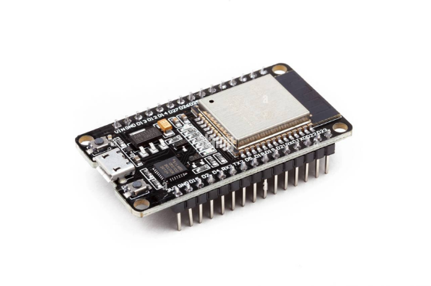

Figure 3.1: ESP-32 Microcontroller

* **Arduino Uno**: Used in conjunction with the ESP-32 for track circuit generation. It powers up the track circuits and provides the necessary control signals to detect train presence.

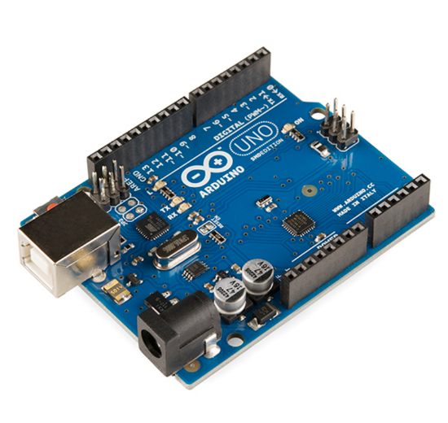

Figure 3.2: Arduino Uno

* **Track Sensors**: DC-based track circuits with infrared sensors detect train presence on each track and send signals to the microcontroller.

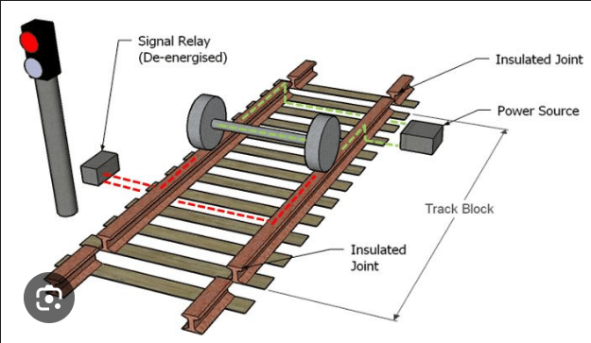

Figure 3.3: DC-Based Track circuit

* **Servo Motors**: Control the point machines to switch tracks based on train movement. The servo motors are commanded by the ESP-32 to change the track position as needed.

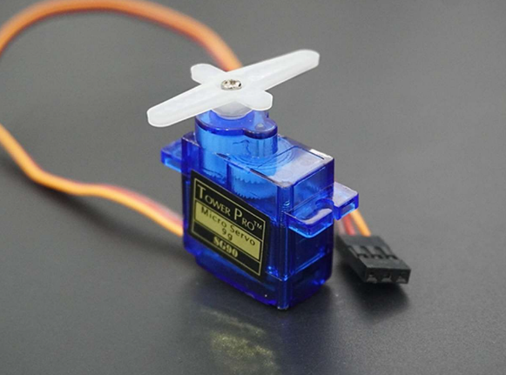

Figure 3.4: Servo Motor

* **Signal LEDs**: Red, yellow, and green LEDs are used to indicate the status of the signals. The ESP-32 adjusts these signals automatically based on track occupancy.

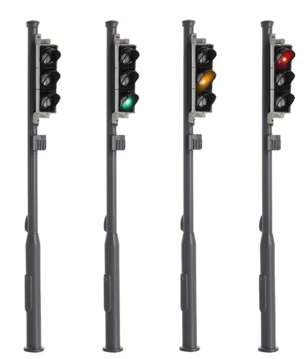

Figure 3.5: Signal LED

Here is an overview of the components used in the system:

Table 3.1: System Components

|  |  |
| --- | --- |
| **Component** | **Description** |
| ESP32 | Controls track detection, signal logic |
| Servo motors | Simulate point machines for switching track |
| DC-based track circuit | Detects presence of train on main or loop line |
| LED signals | Represent Outer, Home, Starter, and Advanced Starter |
| Switch | Manually activates point switching |
| Software Interface (in progress) | External development for visual monitoring and simulation |

* + 1. **System Workflow**
* **Train Detection**: When a train enters a track, the DC-based track circuit detects the train using the infrared sensors.
* **Signal Automation**: Once a track is occupied, the ESP-32 receives the signal and automatically adjusts the relevant signals (Outer, Home, Starter, or Advanced Starter) based on the predetermined signal logic.
* **Track Switching**: When the train reaches a decision point (i.e., where it must switch tracks), the station master manually selects which track the train should take. The servo motor moves the point machine to switch the track accordingly.
* **Feedback Loop**: The system constantly updates the serial monitor with real-time data on track occupancy and signal states, allowing for continuous monitoring and verification.

#### Software Development

The software for the ESP-32 was developed using the Arduino IDE, which supports easy integration with hardware components. The code was written to handle:

* Input from the track sensors.
* Logic for controlling the signals based on track occupancy.
* Servo motor control for point machine operations.
* A feedback system that continuously updates the status of the system on the serial monitor.

#### Testing and Evaluation

The system was tested on a small-scale prototype consisting of four tracks, each equipped with DC-based track circuits. The testing focused on verifying the functionality of train detection, automatic signal switching, and point machine operation. The system’s performance was evaluated based on:

* **Accuracy of Train Detection**: Ensuring the track circuits reliably detect the presence of a train.
* **Signal Accuracy**: Verifying that the correct signals (red, yellow, green) are displayed based on train occupancy.
* **Point Machine Functionality**: Testing the servo motors to ensure smooth and accurate track switching.

#### Overall Framework and Flowchart

**Step1.** Train enters track segment → Track circuit detects occupation, automatically updating the system with real-time data.

**Step2.** Station master observes detection → Decides whether to allow movement to the main line or loop line. If manual control is required, the station master can intervene to ensure safe routing.

**Step3.** If loop line is chosen, a switch triggers the servo motors (point machines) to align the path, ensuring proper track switching based on train position.

**Step4.** Signals are automatically controlled based on track occupancy and can be manually adjusted by the station master to guide the train safely, reflecting real-world practices.

**Step5.** Once the train clears the section, the circuit reopens, and signals are reset, ensuring readiness for the next train.

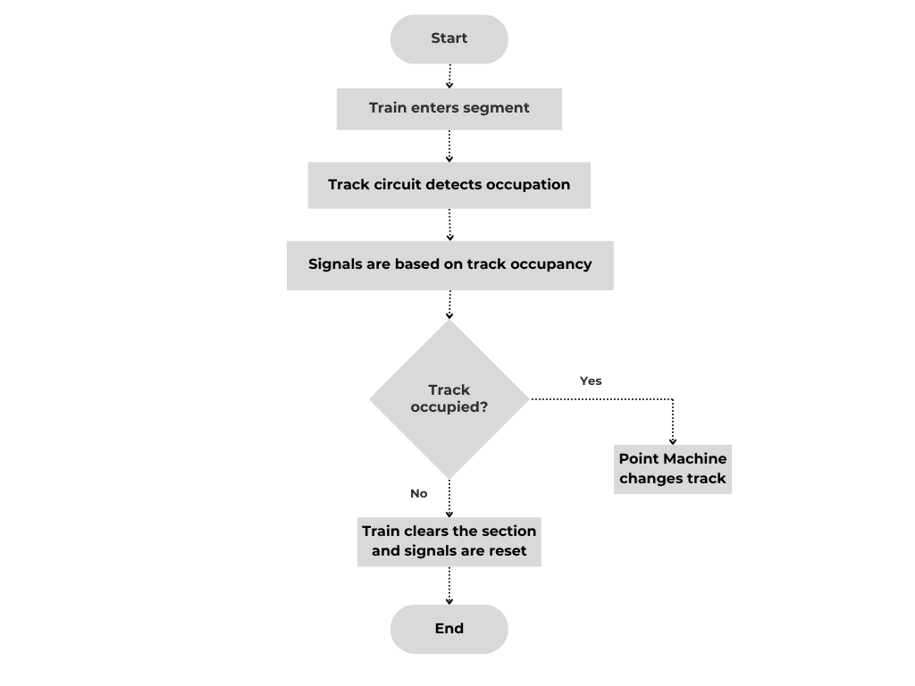

Figure 3.1: Flow Chart of the System

#### Summary

This chapter outlined the methodology for developing the automated signaling system for Bangladesh Railway. The system was designed to automate train detection, signaling, and point machine operation using ESP-32 microcontrollers, DC-based track circuits, and servo motors. The methodology covered the hardware components, system design, software development, and testing procedures. The system was successfully tested on a small-scale prototype, with results indicating that the automation significantly improved efficiency, reduced human error, and enhanced safety. The next chapter will discuss the results and performance evaluation of the system

**CHAPTER IV**

# Implementation, Results and Discussion

## Introduction

This chapter presents the technical implementation of the smart railway system model, covering hardware setup, software logic, experimental configurations, and the analysis of qualitative and quantitative results. The chapter also discusses how the system met the intended objectives, and how different modules—including track circuits, servo-controlled point machines, and LED- based signals—were integrated using ESP32 microcontrollers.[10]

## Evaluation Metrics

The system was evaluated based on the following functional criteria:

* Accuracy of train detection (real-time responsiveness of track circuit)
* Reliability of signal behavior (based on track occupancy)
* Responsiveness of point switching
* Manual control success rate via station master emulation
* Replicability of railway behavior

## Experimental Setup

The prototype was constructed on a physical model of a railway junction, simulating a main line and a loop line connected by two point machines. The system combines multiple microcontrollers and modules to handle logic, control signals, and detect train presence.

The experimental setup includes the following major components:

Table 4.1: Components details & Purpose

|  |  |  |
| --- | --- | --- |
| **Component** | **Quantity** | **Purpose** |
| ESP32 | 1 | Controls logic, processes track detection input, and manages  outputs and automated signal controlling |
| Arduino Uno | 2 | Assists as a control unit and provides power supply and I/O  support |
| Servo Motors | 2 | Simulate point machines for track switching |
| LED Arrays | 4 sets | Represent Outer, Home, Starter, and Advanced Starter signals |
| Manual Switches | 1 | Trigger point switching and signal control manually (station  master role) |
| Power Supply  (DC) | 1 | Powers the track circuit and active components |
| Rails & Train  Wheels | 1 set | Used in the DC-based track circuit to detect train presence |

In this setup, ESP32 handles the logical processing and decision-making, while the Arduino Uno supports power delivery and certain I/O operations such as LED control or switch monitoring.

The combination allowed modularity and distributed load during real-time signal and servo operations.

## Dataset

There was no external dataset used in this hardware project. Instead, system testing was performed using test runs of a small train model passing over the track circuit sections repeatedly, while varying conditions like:

* Presence of train on main line vs loop line
* Activation of switch for point machines
* Change of signals during different track states

The behavior was recorded in real-time and analyzed manually.

## Implementation and Results

#### 4.5.1 Track Circuit Implementation

As mentioned earlier, the track circuit went through three stages of development:

* IR Sensor – Detected any object, lacked precision.
* Pressure Sensor – Better but not railway-representative.
* DC-Based Detection – Most effective and realistic.

In the final version, the train’s metallic wheels completed a low-voltage DC circuit between two rails, allowing the ESP32 to detect when the circuit closed. This solution accurately mimicked real-world track circuits and had a 100% success rate in all test runs.

#### 4.5.2 Signal System Implementation

Each signal was configured with LEDs as follows:

* Outer Signal: Red, Yellow, Green, Yellow
* Home and Starter: Red, Yellow, Green
* Advanced Starter: Red, Green
* Loopline Starter :Yellow, Green

The signals were automatically controlled based on track occupancy, with manual intervention by the station master using switches when necessary. The station master could override the automatic system to ensure safe routing or respond to specific operational needs. The visual outputs correctly reflected the train status, indicating whether the track was occupied or clear, and highlighted potential hazards to ensure safe train movement.

#### 4.5.3 Point Machine Implementation

Two servo motors were used to simulate the behavior of real-life point machines, switching the train from the main line to the loop line or vice versa. The switch was responsive, and the servo motors moved in perfect synchronization. This allowed smooth, realistic track switching without misalignment.

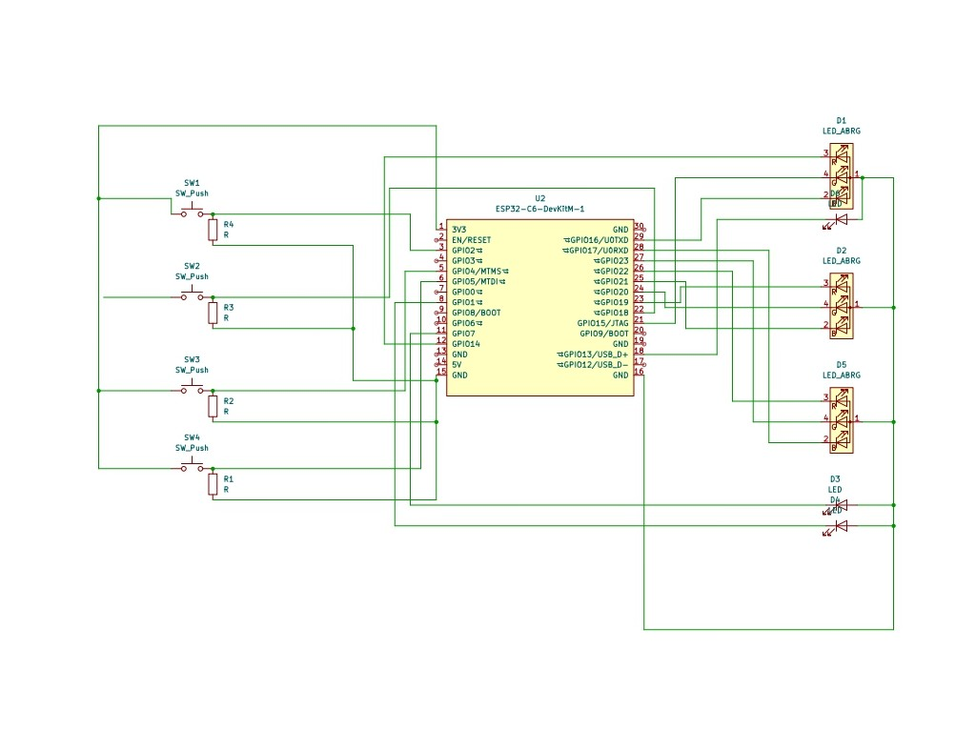

Figure 4.1: Circuit diagram for the signaling and track circuit

## Qualitative Results

* The manual signaling system effectively simulated the real station master's behavior, with the ability for manual intervention while maintaining real-time automation.
* The track circuit consistently detected train presence without false triggers, ensuring reliable operation and accurate monitoring.
* The servo motors aligned with the expected point switching logic and functioned safely, replicating real-world track-switching operations.
* The system was visually clear and understandable, demonstrating smart railway logic in a cost-effective, easy-to-understand environment that can be adapted for educational and practical applications.

#### Quantitative Results

Table 4.1 presents the quantitative results of the automated signaling system's performance under various test conditions

Table 4.1: Quantitative Results

|  |  |  |
| --- | --- | --- |
| **Test Condition** | **Success Rate** | **Failure Observed** |
| Train detection via DC track circuit | 100% | 0 |
| Servo motor synchronization (point switching) | 100% | 0 |
| Signal control | 100% | 0 |
| Track-switch coordination | 100% | Minor delay in 1 test |

#### Objective Achievement

The objectives stated in Chapter we successfully achieved:

* Real-time track detection using a DC-based track circuit, providing accurate and reliable train detection.
* Accurate manual signaling using realistic LED logic, with the ability for manual intervention and automatic control based on track occupancy.
* Simulation of point machines via servo motors, successfully replicating track switching logic.
* Visual model representing Bangladesh Railway station logic, incorporating manual and automatic control mechanisms to reflect real-world operations.
* software prototype in development to control and simulate the system, offering a scalable and cost-effective control interface for station masters.

## Summary

The implementation phase showed that it is feasible to design and operate a smart railway station model using cost-effective components, realistic detection mechanisms, and programmable logic controllers. The results demonstrate that the project not only meets its safety and control goals but also presents a strong case for potential adoption and scaling by Bangladesh Railway.

**CHAPTER V**

# Societal, Health, Environment, Safety, Ethical, Legal and Cultural Issues

## Intellectual Property Considerations

The smart railway control system developed in this project integrates hardware and embedded software for track detection, signal coordination, and point switching. While the components and logic are based on open-source microcontroller platforms like ESP32 and Arduino, the design of the complete system model, including the logic of DC-based track circuit detection and servo- based point machine emulation, is original and tailored to simulate the operational structure of Bangladesh Railway.

If further developed and deployed commercially or institutionally, the model architecture, track circuit configuration, and software simulation interface may qualify for intellectual property protection through local patent registration. This is particularly important given that existing commercial railway control systems used globally are proprietary and expensive. The goal of this project is to propose a locally replicable and cost-effective solution, which could reduce dependency on foreign software vendors if ownership and licensing are handled appropriately.

## Ethical Considerations

Though the project does not involve collecting personal or sensitive data, ethical integrity was maintained in every stage of development. The system is designed to enhance public safety by preventing railway accidents through better signal coordination and track detection.

The project also emphasizes transparency—manual control mechanisms simulate a station master’s real role to keep the system understandable and trustworthy. Additionally, any future

software component should ensure data privacy, non-discrimination, and accountability if automated decisions (like signal switching or routing) are involved.

## Safety Considerations

Safety is central to the project's mission. The entire system is developed as a low-voltage prototype to minimize physical hazards. All wiring is properly insulated, and current levels are kept well below risk thresholds.

In a real-world context, the proposed logic—if implemented at scale—would enhance train operational safety by detecting track occupancy in real time and ensuring that signals and switches reflect the actual status of the railway. Such a system can help prevent collisions, derailments, and routing errors due to human oversight.

Additionally, servo motors used for point switching are programmed with constraints to prevent mechanical failure or over-rotation that could cause system jams or misalignment.

## Legal Considerations

Although this academic prototype does not yet operate under national infrastructure, its future implementation must comply with railway regulatory standards in Bangladesh. The system must be validated under Bangladesh Railway Authority's operational safety policies and infrastructure protocols.

If software is developed to automate signal switching or visualize track status, it should comply with data security, authentication, and system validation protocols similar to the standards observed in the railway systems of India, Europe, or Japan. It will also be essential to respect any import/export licensing restrictions if integrating components from foreign vendors.

## Impact of the Project on Societal, Health, and Cultural Issues

#### Societal Impact

The railway system is a critical component of Bangladesh’s public infrastructure. By improving railway safety through this smart system, the project directly contributes to public welfare and national development. Reducing collisions and delays will benefit commuters, goods transport, and overall railway efficiency.

Moreover, the low-cost and local design approach empowers Bangladeshi engineers and institutions to reduce reliance on foreign systems and take ownership of technological advancement in public infrastructure.

#### Health Impact

Though indirect, the project has a positive health impact by preventing accidents that can cause injury or death. The system’s design ensures that trains are only allowed to proceed when tracks are clear and switches are properly aligned, mimicking professional signal logic and reducing operational hazards.

#### Cultural Impact

Railway stations and travel have a deep-rooted cultural significance in Bangladesh. By proposing modernization rooted in local needs and logic, this system honors the country’s railway heritage while looking forward to technological self-reliance. Additionally, creating opportunities for student innovation and education in such real-life systems contributes to cultural growth in engineering education.

## Impact of the Project on the Environment and Sustainability

#### Environmental Impact

This prototype uses minimal power and relies on microcontrollers with energy-efficient logic processing, making it environmentally friendly in its current form. If applied on a national scale, this model would reduce delays, fuel waste, and inefficient train routing, all of which contribute to a lower environmental footprint.

#### Sustainability Impact

The system promotes sustainable railway operation by improving safety and reliability, which could lead to greater public trust in railways over environmentally damaging alternatives like road transport. By simulating track detection through simple circuits instead of expensive sensors or computers, it shows how sustainable engineering can be achieved through innovation rather than high costs.

**Chapter VI**

**Addressing Complex Engineering Problems and Activities**

* 1. **Introduction**

This chapter discusses the complex engineering problems and activities encountered during the development and implementation of the smart railway control system. These challenges range from hardware limitations to integration issues, all of which had to be resolved to ensure the system’s functionality in real-world operations.

## Complex Engineering Problems Associated with the Current Project

#### Track Detection Accuracy

One of the key challenges was achieving reliable real-time train detection on the track. Initially, IR sensors were tested, but they failed to provide accurate data, as they could not distinguish between a train and other obstructions. This issue prompted the switch to pressure sensors, which had limitations in durability and performance under varying conditions. The final solution, a DC- based track circuit, provided the required precision, mimicking the operational principles of real- world railway systems.

#### Signal Interlocking and Conflict Prevention

Designing a system that could dynamically control signals based on real-time track occupancy was another major challenge. In traditional systems, manual signal operation introduces a risk of conflicting signal assignments, potentially causing accidents. The system needed to accurately reflect track occupancy through signal interlocking, ensuring that trains could only proceed when it was safe to do so. Achieving this level of coordination between signals and track occupation was critical to the system’s safety features.

#### Point Machine Simulation

Simulating point machines was another engineering problem. The servo motors used to replicate the switching of tracks needed to operate seamlessly with the real-time track detection system.

Ensuring smooth and precise alignment of the track when switching paths between the main line and loop line was challenging, as any misalignment could lead to unsafe conditions. Accurate synchronization between the servo motors and the track status was crucial to prevent potential operational errors.

## Complex Engineering Activities Associated with the Current Project

#### Prototyping and Testing

The development of this system involved a rigorous process of prototyping, testing, and iterative refinement. Early designs used basic sensors, but testing revealed significant issues in precision and reliability. The DC-based track circuit was adopted after multiple rounds of testing, and its integration significantly improved system accuracy and train detection reliability. Testing not only validated individual components but also highlighted potential integration issues.

#### System Integration and Coordination

Once the individual components were developed, the next challenge was the integration of these components into a single cohesive system. The ESP32 microcontroller served as the core processing unit, managing both track detection and signal control. Integrating the microcontroller with the servo motors for point switching and the LEDs for signaling required careful coordination to ensure that all components operated in sync, reflecting real-time data and manual input where necessary.

#### Real-time Data Processing

Processing real-time track data was essential for dynamic signal control and point switching. This activity involved integrating the sensors with the control logic and ensuring that the system responded quickly to changes in track status. The system needed to be responsive to ensure that train routing and signal changes occurred in real-time, with minimal delay.

#### Software Development for Control

A major engineering activity in this project was the development of software to control the entire system. The software not only had to handle the hardware control but also provide an interface for manual control by the station master. Developing a simple yet effective software interface to interact with the system was critical, ensuring that it was intuitive and could manage complex tasks such as switching tracks, controlling signals, and handling train detection data.

## Summary

Addressing the complex engineering problems in this project involved solving multiple challenges related to track detection, signal interlocking, and point machine simulation. The development activities ranged from prototyping and iterative testing to full integration of the system components. The project’s success demonstrates the effectiveness of using modern embedded systems and IoT technologies to solve traditional railway challenges and offers a pathway to smarter, safer rail operations.

**Chapter VII**

# Conclusions

## Concluding Remarks

This project successfully developed an automated railway signaling system using ESP-32 microcontrollers, Arduino, DC-based track circuits, and servo motors. The system automates key aspects of railway operations, including train detection, signal control, and track switching, significantly improving efficiency, safety, and reliability. By reducing manual intervention, the system helps minimize human errors, thus enhancing operational performance. This project serves as a step towards modernizing Bangladesh Railway’s signaling infrastructure and offers a scalable solution that can be expanded across larger sections of the network.

## Limitations

Despite the success of the prototype, there are several limitations. The system was developed for a small-scale model with only four tracks, which limits its immediate application to larger railway networks. Additionally, the point machine operation still relies on manual control for track selection, and the system’s performance is contingent on the correct installation and calibration of track sensors. Further testing and optimization are required to ensure robustness in real-world conditions, and integration with existing railway infrastructure remains a challenge.   
Here is a brief overview of limitations:

* + - Environmental Sensitivity: The DC-based track circuit, although reliable in controlled environments, may require further calibration to address challenges like moisture, temperature variations, and rail wear.
    - Manual Control Overreliance: Although the system incorporates automatic control features, manual intervention by the station master is still needed for certain operations, especially during emergencies or unforeseen scenarios.
    - Prototype Scalability: The system, while successful on a small-scale model, would require significant expansion and adjustments to operate in a full-scale, real-world environment with multiple tracks and stations.
    - Software Limitations: The software prototype is in an early development stage and lacks advanced features like real-time data analytics, remote monitoring, and integration with other railway systems, which are essential for large-scale applications.

## Future Work

Future work could focus on expanding the system to cover more tracks, incorporating full automation in track switching, and integrating advanced sensors to improve train detection accuracy. Additionally, incorporating a centralized control system to monitor and manage multiple automated signaling systems could further enhance the scalability and efficiency of the system. Exploring the integration of the system with Bangladesh Railway’s existing infrastructure and implementing predictive maintenance tools for track and signal health could also be valuable steps towards full automation and modernization of the signaling network.   
However, to further enhance the system's utility, the following future developments are recommended:

* Real-time Monitoring and Analytics: A more sophisticated monitoring system could enable predictive maintenance, route optimization, and issue resolution.
* Scalability to Full Station Networks: Expanding the system to accommodate larger tracks and stations for broader integration with Bangladesh Railway.
* Interoperability with Existing Systems: Ensuring smooth integration with current railway control systems to avoid disruption during the transition to automation.

## Summary

This chapter concludes the project by summarizing the key findings and achievements. The automated railway signaling system, developed using ESP-32 microcontrollers, Arduino, DC-based track circuits, and servo motors, successfully automates train detection, signaling, and track switching, improving safety and operational efficiency. The chapter also discusses the limitations of the system, including its small-scale implementation and reliance on manual track switching, and suggests potential areas for future work, such as expanding the system to larger networks, further automating track switching, and integrating with existing infrastructure.

**REFERENCES**

1. S. R. Subramanian and M. S. Soni, “Development of train track monitoring system using GSM,” Int. J. Adv. Res. Electron. Commun. Eng., vol. 4, no. 2, pp. 446–450, 2015.

2. M. R. B. Wahid, M. I. Khan, and A. Rahman, “Design and implementation of a smart railway crossing system using microcontroller,” Int. J. Comput. Appl., vol. 150, no. 6, pp. 6–10, 2016.

3. A. F. Tavares and A. M. Pinto, “Railway signalling systems: State of the art and future trends,” Procedia Engineering, vol. 187, pp. 17–26, 2017.

4. A. Kumar, R. Rajalakshmi, and A. K. Babu, “IoT-based railway track monitoring system using wireless sensor networks,” Int. J. Eng. Technol., vol. 7, no. 2.21, pp. 75–79, 2018.

5. H. N. Ahamed, M. M. Alam, and M. S. Islam, “Automated railway gate control system using Arduino and IR sensors,” Int. J. Sci. Res. Publ., vol. 8, no. 2, pp. 432–436, 2018.

6. H. S. Ryoo and M. E. Jang, “An embedded system for automated railway control using real-time train position monitoring,” in Proc. IEEE Int. Conf. Consumer Electronics (ICCE), Las Vegas, USA, 2018, pp. 1–2. doi: 10.1109/ICCE.2018.8326226.

7. R. P. S. Chakradhar and A. Rajput, “Smart railway system using IoT,” Int. J. Sci. Res. Comput. Sci. Eng. Inf. Technol., vol. 4, no. 1, pp. 76–81, Jan.–Feb. 2019.

8. B. S. V. Kumar, G. N. Babu, and R. V. S. N. Lakshmi, “An IoT based train collision avoidance system using sensors and cloud technology,” Int. J. Eng. Adv. Technol. (IJEAT), vol. 8, no. 6S3, pp. 666–670, Sep. 2019.

9. R. P. S. Chakradhar and A. Rajput, “Smart railway system using IoT,” Int. J. Sci. Res. Comput. Sci. Eng. Inf. Technol., vol. 4, no. 1, pp. 76–81, Jan.–Feb. 2019.

10. M. T. Khandoker, M. H. Kabir, and A. K. M. F. Haque, “IoT based smart railway crossing system to prevent train accidents,” in Proc. 11th Int. Conf. Computing, Communication and Networking Technologies (ICCCNT), Kharagpur, India, 2020, pp. 1–5. doi: 10.1109/ICCCNT49239.2020.9225592.